**SHOP DELIVERY MANAGEMENT SYSTEM**

***A Mini Project Report Submitted by***

**Sachin Prabhu K Sheldon D’souza**

**(4NM16CS121) (4NM16CS135)**

**Sanath Stalin Lobo**

**(4NM16CS129) (4NM16CS152)**

**Shariq Ali BN Roidon D’souza**

**(4NM16CS134) (4NM16CS208)**

#### 

#### 

**UNDER THE GUIDANCE OF**

#### Dr……

#### Associate Professor

**Department of Artificial Intelligence and Machine Learning Engineering**

***In partial fulfillment of the requirements for the***

***Subject Name with Code***

|  |
| --- |
|  |
| Nitte(DU) established under Section 3 of UGC Act 1956 | Accredited with ‘A+’ Grade by NAAC |

08258 - 281039 – 281263, Fax: 08258 – 281265

:



**April 2020**

i



(ISO 9001:2015 Certified), Accredited with ‘A’ Grade by NAAC

: 08258 - 281039 – 281263, Fax: 08258 – 281265

**Department of Artificial Intelligence and Machine Learning Engineering**

B.E. CSE Program Accredited by NBA, New Delhi from 1-7-2018 to 30-6-2021

CERTIFICATE

*Certified that the mini project work entitled*

***“Shop Delivery Management System”***

*is a bonafide work carried out by*

***Sachin Prabhu K Sanath Shariq Ali BN***

***(4NM16CS121) (4NM16CS129) (4NM16CS134)***

***Sheldon Francis Dsouza Stalin Lobo Roidon Gladson Dsouza***

***(4NM16CS135) (4NM16CS152) (4NM16CS208)***

*in partial fulfilment of the requirements for the award of*

***Bachelor of Engineering Degree*** *in* ***Artificial Intelligence and Machine Learning Engineering***

*prescribed by* ***Visvesvaraya Technological University, Belgaum***

*during the year 2019-2020.*

*It is certified that all corrections/suggestions indicated for Internal Assessment have been*

*incorporated in the report deposited in the departmental library.*

*The mini project report has been approved as it satisfies the academic requirements in respect of the*

*mini project work prescribed for the Bachelor of Engineering Degree.*

**Signature of Guide Signature of HOD**

**Evaluation**

**Name of the Examiners Signature with Date**

*1.*

*2.*

## ACKNOWLEDGEMENT

We believe that our mini project will be complete only after we thank the people who have contributed to make this mini project successful.

First and foremost, our sincere thanks to our beloved principal, **Dr. Niranjan N. Chiplunkar** for giving us an opportunity to carry out our mini project work at our college and providing us with all the needed facilities.

I acknowledge the support and valuable inputs given by**, Dr…………** the Head of the Department, Artificial Intelligence and Machine Learning Engineering, NMAMIT, Nitte

We express our deep sense of gratitude and indebtedness to our guide **Mr. …………,** Assistant Professor Artificial Intelligence and Machine Learning Engineering, for his inspiring guidance, constant encouragement, support and suggestions for improvement during the course for our mini project.

We also thank all those who have supported us throughout the entire duration of our mini project.

Finally, we thank the staff members of the Department of Artificial Intelligence and Machine Learning Engineering and all our friends for their honest opinions and suggestions throughout the course of our mini mini project.

#### Sachin Prabhu K

#### Sanath

#### Shariq Ali BN

#### Shedon Francis D’souza

#### Stalin Lobo

#### Roidon Gladson D’souza

#### 

#### ABSTRACT

Online shopping is becoming increasingly popular for variety of reasons. There are certainly outside factors such as increasing gas prices, difficulty in getting to traditional stores and hassles often associated with shopping malls and other traditional stores to contribute to the increased interest in online shopping. Consumers can get full information about the product with its reviews being passed by the existing users. If one wants to buy a product he/she is no longer limited to asking the friends and families because there are many products reviews on the web which gives opinions of the existing users of the product. Online shopping sites contain wide variety of goods both high quality and mild quality keeping in mind the level of people. The local shopkeepers are suffering ever since the introduction of online shopping. But there are some specialized products which only local shopkeepers sell. Hence shopkeepers can highlight these products in the current proposed system. This will attract a lot of local customers and make a huge business out of it by delivering products to customers doorstep quicker than online shopping sites.







vii

**LIST OF FIGURES**

Figure 2.1: Indicator matrix for collaborative filtering 6

Figure 5.1: High level design architecture **Error! Bookmark not defined.**

Figure 5.2: Sequence diagram for customer **Error! Bookmark not defined.**

Figure 5.3: Use case diagram for customer **Error! Bookmark not defined.**

Figure 8.1: Customer signup 22

Figure 8.2: Search 23

Figure 8.3: Shop and products 24

Figure 8.4: Selecting the shop and adding item to cart 25

Figure 8.5: Shop items 26

viii

## CHAPTER 1 INTRODUCTION

Delivering items to the doorsteps of people has become a growing trend in modern day. It saves the valuable time of the customers and it lets businessmen have an extra source of income. In fact, many shops give customers their card promising delivery of items to the customer’s doorstep. But calling the shopkeeper and placing their order is inconvenient to the both parties. There is lack of clarity and the shopkeeper must hire dedicated staff to receive the calls. They may even pick the calls themselves when they lack resources to do so. Hence, clearly there is a need for a platform that manages these tasks for the both parties. That is what the app Shop Delivery Management System aims to do. It aims to let the shopkeepers sign up to the system and set up a virtual shop. Any customer can just browse through these shops and order the products they desire. These lists of products are sent to the shopkeepers along with the customer address without having shopkeepers lifting a finger. Products are recommended to the user based on collaborative filtering technique.

### OVERVIEW

Online shopping advancements have been so drastic that it has evolved to be a part of our life. Today customer doesn’t drive down to some shop for buying a product but preferably check over the internet for price, offers, reviews and order online. In most of the metro Politian cities items are purchased from shops for their basic needs of day to day life. The current system working procedure in those cities is where customer calls/drives down to shop to order the items by providing the shopkeeper a deliverable address and then a delivery person delivers the order to customer’s door step, as this system works totally offline and has lot of drawbacks. The major drawbacks in current offline system are repeated calls from and to customer, if multiple orders are placed from same locality the delivery person travels multiple times, there is no track of order, etc. This system proposes an web application for item ordering and delivery management system, where customer can order over an application by searching the nearby shops which provide the service and make payment. This proposed system helps in overcoming the major drawbacks of current system. This application provides assistance modules for shopkeeper. It provides a delivery module which helps delivery person to deliver the items to number of places.

### PROBLEM STATEMENT

To create a web app that let’s costumers to place their orders to the shopkeepers in their surrounding area. In order to achieve this, costumers must input their location. Based on customer location, the system will recommend shops and products available near the customer. the system will recommend shops and products available near the customer. The customer will also receive recommendations based on what the hottest selling products in the area are. There would also be recommendations based on customer purchase and cart item history using collaborative approach and the need to repurchase the products.

Shopkeepers must setup the location as well as the shop details. The preferred range of delivery must also be entered in order to filter out customers who aren’t in their range of delivery service.

The system must also use machine learning algorithms on server side to get customized recommendation for the customer.

### STUDY AREA

The SDMS aims to provide convenience and ease of use to customers to make it more attractive to customers. Recommendation system to recommend products based on the customer’s tastes would be a brilliant way to do just that. Hence, study over various recommendation systems were made before settling down with a simple collaborative method.

The recommendation system uses KNN method to find the most similar users and recommends products based on the tastes of the most similar users. Users can discover tailor made recommendations that happens to be just what they needed and makes user life easier.

### OBJECTIVE

In this mini project, we aim to create an web app that allows users to go through nearby shops and browse the items in these shops. Users can purchase the items if they want to by sending the order list to the shopkeepers. The objectives of the mini project are:

* To develop a front end UI for both shops as well as customers
* To allow customers to locate the shops on a map and select these shops
* To allow customers to order items from any shops and writing reviews about the shop
* To let shops receive the order lists from customers and indicate that item is on the way
* To let customers experience personalized recommendations based on their tastes using machine

Learning,

### MOTIVATION

Due to the rise in online shopping at a fairly cheaper rate than offline shopping, the business of the local shopkeepers has been under huge amount of trouble. There are some items that only local shopkeepers have which cannot be obtained through online. Hence these items can be delivered to customers doorstep.

### ORGANIZATION OF THE CHAPTERS

The project report has been organized under nine chapters, which are as follows:

**Chapter I:** Introduces to the main idea of the project. It gives a brief knowledge about the aim and methodology of the same.

**Chapter II:** It includes literature survey of related works.

**Chapter III:** Discusses the system requirements that are needed for the project. These include functional requirements, non-functional requirements, user requirements and hardware requirements.

**Chapter IV:** Includes the system design details which includes flowchart, sequence diagram.

**Chapter V:** Includes the implementation details of the project, application is explained in detail. It also deals with software approach.

**Chapter VI:** Deals with system testing concepts and the various test cases for the project.

**Chapter VII:** Includes the screenshots of the application and the database.

**Chapter VIII:** Discuss the results of the project.

**Chapter IX** outlines conclusions and future work that can be done

### EXISTING SYSTEM

## CHAPTER 2 LITERATURE SURVEY

Delivery Management is the management of communication between the shopkeepers and the customers in terms of buying and delivering of products. The app aims to provide simple means of setting up a virtual shop that anyone can buy products from and have it delivered to their home. The primary focus of this review is to analyze the advantages and disadvantages of ordering products through the system. The review also focuses on current Machine Learning recommendation system approach available and the approach chosen.

Paper [1] compares between online and offline shopping and takes several factors into consideration regarding their pros and cons. [1] mentions risk of receiving faulty goods, long delivery time and not having enough information as the con of shopping online. These concerns are invalid or minimized regarding Shop Delivery Management System(SDMS) as the products are delivered from nearby shops. Hence, there is little risk with the information of the shop available to customers. The delivery time is also reduced to within mere hours and hence, SDMS again has superior advantage. The costumers are also more likely to purchase everyday products that they already know about and the concern about lack of information is invalid. On the flip side, [1] mentions low cost of products compared to retail as an advantage of online shopping- which is not true regarding SDMS. With addition of delivery charges the products would actually cost more. There already exists apps such as Grocer and BigBasket which delivers grocery to customers at lower price. But these apps are lacking in terms of reducing risks, which SDMS excels in

There are various approaches of building a Machine Learning System. These approaches include:

**Popularity based**:

Easiest way to build a recommendation system is popularity based, simply over all the products that are popular, So how to identify popular products, which could be identified by which are all the products that are bought most.

**Classification based:**

Second way to build a recommendation system is classification model , In that use feature of both users as well as products in order to predict whether this product liked or not by the user.

When new users come, our classifier will give a binary value of that product liked by this user or not, In such a way that we can recommend a product to the user .

**Collaborative filtering:**

Collaborative filtering models which are based on assumption that people like things similar to other things they like, and things that are liked by other people with similar taste.

Paper [2] talks about building **Collaborative filtering** approach that would be implemented in SDMS. The basic idea is that if two people like same products, one of them would like the other products brought by the other person as well. This approach is clearly more fitting SDMS compared to other approaches. [2] also talks about the different techniques used to get superior recommendation such as **Dithering** and **Anti-Flood** to prevent giving boring and repetitive recommendations which would be applied in SDMS.

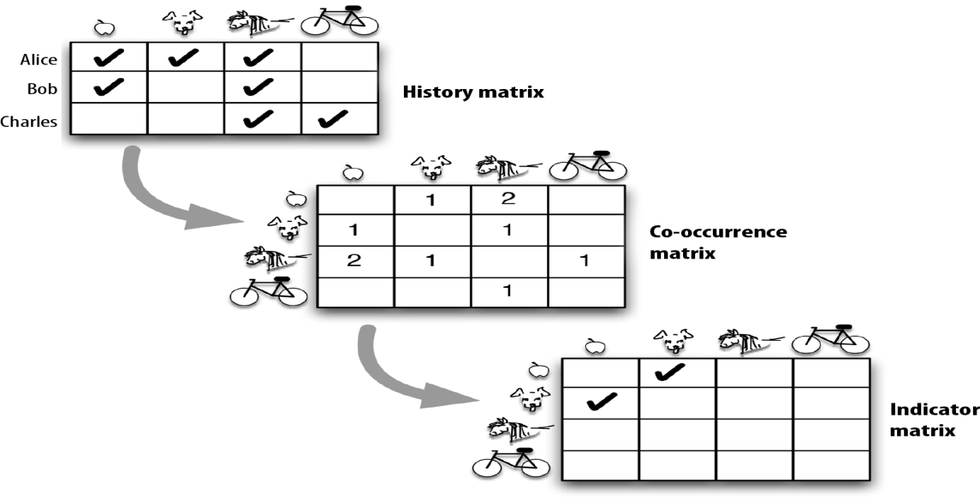

*Fig. 2.1 indicator matrix for Collaborative approach*

### PROPOSED SYSTEM

A system that lets customers create an account and order items from the surrounding shops. The focus of the system is to act as a platform to connect customers and shopkeepers on the internet allowing seamless communication from both the parties regarding purchase of items.

The proposed system consists of two types of users: Customers and Shopkeepers. The sign up and login will be handled using Firebase Auth- ensuring security. The customer can choose to login and browse the shops and their products in the surrounding region of the customer. At the home page of the shop, a HTTP request is sent to a cloud function with assistance from CORS to update the recommended items for the user in the firestore database. These recommendations can then be displayed the next time the home page is accessed

Customers can also add products to carts from the shops they fancy. They can then choose to send the list of products to the shopkeeper. Hence, a seamless communication is achieved using the proposed system. Customers can also use the map feature to physically find the surrounding shops in the area along with the items they provide.

## CHAPTER 3 SYSTEM ANALYSIS AND REQUIREMENTS

### SYSTEM ANALYSIS

#### Relevance of Platform

React [8] is very simple and lightweight library that only deals with the view layer. It is not a beast like other MV* frameworks such as Angular or Ember. Any Javascript developer can understand the basics and start developing an awesome web application after only a couple of days reading tutorial.

Firebase [9] manages all data real-time in the database. So, the exchange of data to and fro from the database is easy and quick. Hence, if you are looking to develop mobile apps such as live streaming, chat messaging, etc., you can use Firebase.

Firebase allow syncing the real-time data across all the devices- Android, iOS, and the web without refreshing the screen

#### Relevance of Programming Language

HTML [10] is the programming language that powers the web. And like any language, once you master it, you can begin to create your own content, whether that's simple websites or complex web applications. Using HTML, you create user interface for web applications and mobile applications. HTML was published as a W3C recommendation.

The importance of JavaScript [11] as a web technology can be determined from the fact that it is currently used by 94.5% of all websites. As a client-side programming language, JavaScript helps web developers to make web pages dynamic and interactive by implementing custom client-side scripts. At the same time, the developers can also use cross-platform runtime engines like Node.js to write server-side code in JavaScript. They can even combine JavaScript, HTML5 and CSS3 to create web pages that look good across browsers, platforms, and devices. There are also a number of reasons why each modern web developer must know how to leverage all benefits of JavaScript.

### REQUIREMENT ANALYSIS

#### Scope and Boundary

Requirements are during early stages of a system development as a specification of what should be implemented or as a constraint of some kind of on the system. They may be a user level facility description, a detailed specification of expected system behaviour, a general system property, a specific constraint on the system, and information on how to carry out some computation or a constraint on the development of the system. The end product of the requirement analysis phase is a requirement specification. The requirement specification is a reconstruction of the result of this analysis phase. Its purpose is to communicate this result to others. System requirements are more detailed descriptions of the user requirements. They may serve as the basis for a contract to the implementation of the system and should therefore be a complete and consistent specification of the whole system. In principle, the system requirements should state what the system should do and not how it should be implemented. However, at the level of detail required to specify the system completely, it is virtually impossible to exclude all design information.

### FUNCTIONAL REQUIREMENTS

#### Software Requirements:

* Software: 1. Java Script
  1. React
  2. Realtime firebase database
  3. NodeJS

#### Hardware Requirements

* Operating system: Windows 7 and above.
* RAM: 4GB and above.
* Processor: Intel® Core(TM)2 duo CPU T6500.
* Processor speed: 2.67 GHz.
* CPU: 64-bit operating system.

### NON-FUNCTIONAL REQUIREMENTS:

In [systems engineering](https://en.wikipedia.org/wiki/Systems_engineering) and [requirements engineering,](https://en.wikipedia.org/wiki/Requirements_engineering) a non-functional requirement (NFR) is a [requirement](https://en.wikipedia.org/wiki/Requirement) that specifies criteria that can be used to judge the operation of a system, rather than specific behaviours. Non-functional requirements are conditions under which the system must be able to function and the quality the system must have. It defines how a system is supposed to be.

* Performance
  + With ideal condition website response should be fast and error free.
  + Website performance shall not decrease with time or by usage.
* Flexibility:
  + This website will be easy to learn and use.
  + Is able to analyze and give the output as quickly as possible.
* User-friendly:
  + The users should be able to find their desired video easily.
  + The website’s multiple features should be self explanatory.
* Response Time:
  + The selected video should load and display quickly without consuming much buffer time.
* Understandability:
  + All users can learn to operate the website because of its simplicity.

## CHAPTER 4 SOFTWARE APPROACH

### REACT

React [3]  is an open-source JavaScript library for building  [user interfaces](https://en.wikipedia.org/wiki/User_interfaces). It is maintained by [Facebook](https://en.wikipedia.org/wiki/Facebook) and a community of individual developers and companies. React can be used as a base in the development of [single-page](https://en.wikipedia.org/wiki/Single-page_application) or mobile applications. However, React is only concerned with rendering data to the DOM, and so creating React applications usually requires the use of additional libraries for state management and routing.Redux and React Router are respective examples of such libraries.

### JAVASCRIPT

JavaScript [4] is a lightweight, interpreted, or just-in-time compiled programming language with first-class functions. While it is most well-known as the scripting language for Web pages, many non-browser environments also use it, such as Node.js, Apache CouchDB and Adobe Acrobat. Alongside HTML and CSS, JavaScript is one of the core technologies of the World Wide Web. JavaScript enables interactive web pages and is an essential part of web applications. The vast majority of websites use it for client-side page behavior, and all major web browsers have a dedicated JavaScript engine to execute it.

### 4.3 FIREBASE

Firebase [5] is a mobile and web application development platform developed by Firebase, Inc.in 2011, then acquired by Google in 2014.As of October 2018, the Firebase platform has 18 products, which are used by 1.5 million apps Firebase provides backend as a service. The service provides application developers an API that allows application data to be synchronized across clients and stored on Firebase's cloud. Firebase Storage provides secure file uploads and downloads for Firebase apps, regardless of network quality. The developer can use it to store images, audio, video, or other user-generated content. Firebase Storage is backed by Google Cloud Storage.

### 4.4 NODEJS

Node.js [6] is a cross-platform JavaScript runtime environment that allows developers to build server-side and network applications with JavaScript. Node.js runs the V8 JavaScript engine, the core of Google Chrome, outside of the browser. This allows Node.js to be very performant. Node.js has a unique advantage because frontend developers that write JavaScript for the browser are now able to write the server-side code in addition to the client-side code without the need to learn a completely different language.

### 4.5 K-NEAREST NEIGHBORS ALGORITHM

K-Nearest Neighbors [7] is one of the most basic yet essential classification algorithms in Machine Learning. It belongs to the supervised learning domain and finds intense application in pattern recognition, data mining and intrusion detection.

It is widely disposable in real-life scenarios since it is non-parametric, meaning, it does not make any underlying assumptions about the distribution of data (as opposed to other algorithms such as GMM, which assume a Gaussian distribution of the given data).

We are given some prior data (also called training data), which classifies coordinates into groups identified by an attribute.

**Algorithm**  
Let m be the number of training data samples. Let p be an unknown point.

1. Store the training samples in an array of data points arr[]. This means each element of this array represents a tuple (x, y).
2. for i=0 to m:
3. Calculate Euclidean distance d(arr[i], p).
4. Make set S of K smallest distances obtained. Each of these distances corresponds to an already classified data point.
5. Return the majority label among S.

## CHAPTER 5

### HIGH LEVEL DESIGN ARCHITECHTURE

**SYSTEM DESIGN**

a HTTP request is sent to a cloud function with assistance from CORS to update the recommended items for the user in the firestore database. These recommendations can then be displayed the next time the home page is accessed. The figure 5.1 given below illustrates the high level design architecture.

.

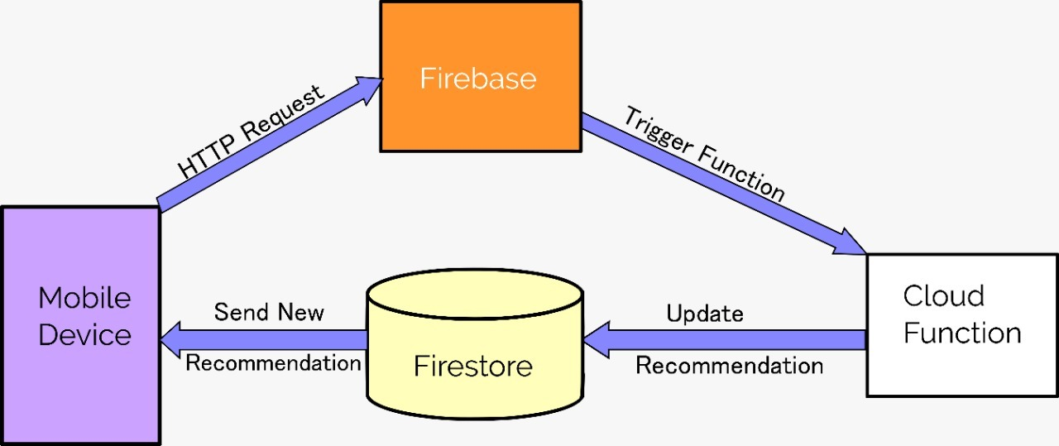

*Figure 5.1: High Level Design Architecture*

### LOW LEVEL DESIGN ARCHITECHTURE

#### Sequence Diagram /DFD

A sequence diagram shows object interaction arranged in time sequence. It describes interactions among classes in terms of an exchange of messages over time. It is also called as event diagram. A sequence diagram is a good way to visualize and validate various run time scenarios. These can help to predict how a system will behave and to discover responsibilities a class may need to have in the process of modelling the new system. Messages are arrows that represent communication between the objects. Lifelines are vertical dashed lines that indicate the object presence over time.

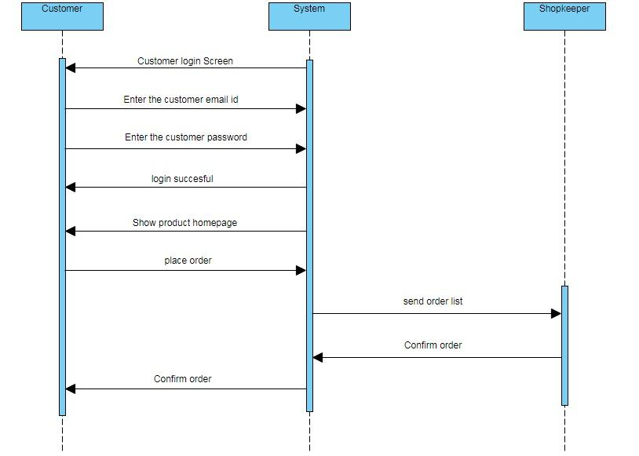

*Figure 5.2: Sequence diagram for Customer*

#### Use case Diagram

A use case diagram is a dynamic or behavior diagram in [UML](https://www.smartdraw.com/uml-diagram/). Use case diagrams model the functionality of a system using actors and use cases. Use cases are a set of actions, services, and functions that the system needs to perform.

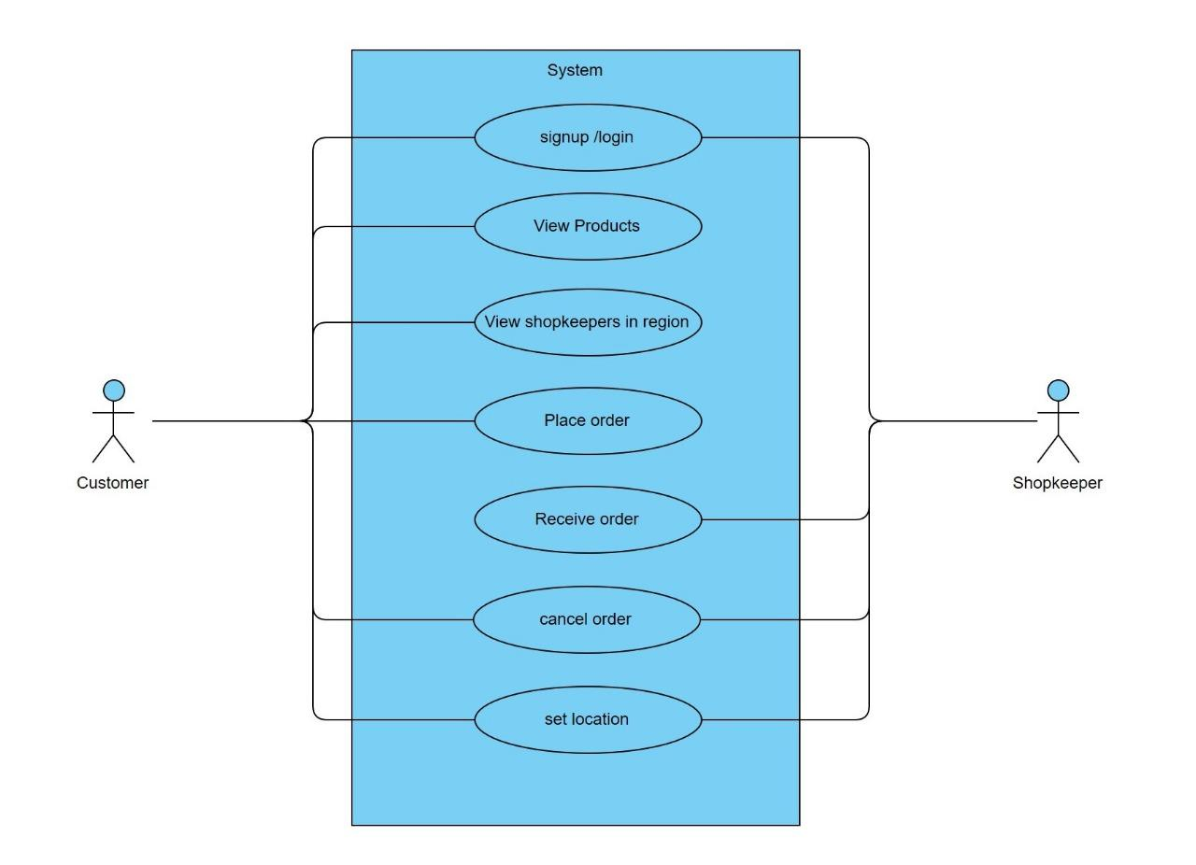

*Figure 5.2: Use case diagram for Customer*

## CHAPTER 6 SYSTEM IMPLEMENTATION

### SOFTWARE APPROACH

#### Design of User Interface

Any product or web application is dynamic and interactive elements that are directly linked to users and impact the business’ tasks and productivity. A web application has to be designed at the comfort level and ease of use with the end user in mind. If a web application is not easily understandable, the efforts go in vain. Maintaining consistency and uniformity in all pages and same goes with styling, is very important. Getting familiarised to the interface is time taking, hence maintaining consistency in elements like style, layout, color and font makes it easier and appealing to the user. [15]

User Interface (UI) Design focuses on anticipating what users might need to do and ensuring that the interface has elements that are easy to access, understand, and use to facilitate those actions. UI brings together concepts from [interaction design](https://www.usability.gov/what-and-why/interaction-design.html), [visual design](https://www.usability.gov/what-and-why/visual-design.html), and [information architecture](https://www.usability.gov/what-and-why/information-architecture.html).

### MODULES

The website mainly contains the following modules: Log in or Sign up, Fetching recommendations, Search by Shop or Product, Add to cart and Order.

* + 1. **Log In or Sign up:**
* Input fields to enter customer details for sign up or log in.
* Connect to firebase auth and register using email id and password.
* Enter the customer details in firestore.
* Let the customer into the app.

#### Fetching recommendations

**Step 1**: If customer, c clicks on product and goes to home page then send http request

to cloud function with c.id.

**Step 2**: Cloud function fetches the user clicks and average clicks stored in firestore for customers.

**Step 3**: Find Euclidean distance between each product click of the c with other customers. If c and other customers don’t have a product click in common, use average clicks of that product as substitute. **Step 4**: Calculate the similarity score for each of these customers compared to c using formula 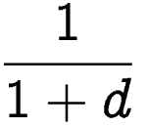 where d is total distance.

**Step 5**: Filter out similar users with score more than 0.8.

**Step 6**: Get the top 5 similar users and calculate the weighted average ratings for each products of these 5 users.

**Step 7**: Update the obtained ratings as recommendations for the user.

**Step 8**: Calculate the average clicks of all products for all users. and update it in firestore.

**Step 9**: End the cloud function.

**Step 10**: Fetch the calculated items and display them with item. info in descending order of the calculated ratings.

#### Search by shops and products

* Allow customers to search by items or shops.
* Query the firestore by name and display the matching substring shops or products.
* Update the clicks for an item in firestore upon clicking on it
* Allow shops to display the items existing in the searched shop.
  + 1. **Add to cart and order**
* Add items to carts by quantity.
* Select the shop which sells the item while adding to cart.
* Update the cart in firestore for the user.
* Select place order to send the list of items to the shopkeepers.
* Add documents in Orders collection with each document having fields: itemid,shopid,customerid,orderid.

## CHAPTER 7 SYSTEM TESTING

### INTRODUCTION

Software testing is a process used to identify the correctness, completeness and quality of the developed software. Testing is the process of questioning a product in order to evaluate it, where the questions are things the tester tries to do with the product and the product answers with its behaviour in reaction to probing of the tester.

Testing phase is performed after coding to detect all the errors and provide quality assurance and ensure reliability of the software. Testing is vital to the success of the system. During testing, the software to be tested is executed with a set of test cases, and the behaviour of the system for the test cases is evaluated to determine if the system is performing as expected. Clearly the success of testing in revealing errors depends critically on the test cases. [13]

### UNIT TESTING

Unit Testing is a level of software testing where individual units/ components of a software are tested. The purpose is to validate that each unit of the software performs as designed. A unit is the smallest testable part of any software. It usually has one or a few inputs and usually a single output. In procedural programming, a unit may be an individual program, function, procedure, etc. In object-oriented programming, the smallest unit is a method, which may belong to a base/ super class, abstract class or derived/ child class. (Some treat a module of an application as a unit. This is to be discouraged as there will probably be many individual units within that module.) Unit testing frameworks, drivers, stubs, and mock/ fake objects are used to assist in unit testing.

The benefits of Unit Testing are:

* Unit testing increases confidence in changing/ maintaining code. If good unit tests are written and if they are run every time any code is changed, we will be able to promptly catch any defects introduced due to the change. Also, if codes are already made less interdependent to make unit testing possible, the unintended impact of changes to any code is less.
* Codes are more reusable. In order to make unit testing possible, codes need to be modular. This means that codes are easier to reuse.
* Development is faster. If you do not have unit testing in place, you write your code and perform that fuzzy ‘developer test’ (You set some breakpoints, fire up the GUI, provide a few inputs that hopefully hit your code and hope that you are all set.) But, if you have unit testing in place, you write the test, write the code and run the test. Writing tests takes time but the time is compensated by the less amount of time it takes to run the tests; You need not fire up the GUI and provide all those inputs. And, of course, unit tests are more reliable than ‘developer tests’. Development is faster in the long run too. The effort required to find and fix defects found during unit testing is very less in comparison to the effort required to fix defects found during system testing or acceptance testing.
* The cost of fixing a defect detected during unit testing is lesser in comparison to that of defects detected at higher levels. Compare the cost (time, effort, destruction, humiliation) of a defect detected during acceptance testing or when the software is live.
* Debugging is easy. When a test fails, only the latest changes need to be debugged. With testing at higher levels, changes made over the span of several days/weeks/months need to be scanned.
* Codes are more reliable. I think there is no need to explain this to a sane person.

### INTEGRATION TESTING

Integration Testing is a level of software testing where individual units are combined and tested as a group. The purpose of this level of testing is to expose faults in the interaction between integrated units. Test drivers and test stubs are used to assist in Integration Testing.

Definitions of integration testing are Integration Testing**:**

* Testing performed to expose defects in the interfaces and in the interactions between integrated components or systems.

Component Integration Testing**:**

* Testing performed to expose defects in the interfaces and interaction between integrated components.

System Integration Testing**:**

* Testing the integration of systems and packages; testing interfaces to external organizations (e.g. Electronic Data Interchange, Internet).

## CHAPTER 8

## RESULTS AND DISCUSSSIONS

### USER INTERFACE

Figure 8.1 shows the signup page used in the project. As can be seen, all the fields are filled and user can sign up in such a simple manner.

After signing up, user can access 3 main pages:

* Home
* Search
* Profile

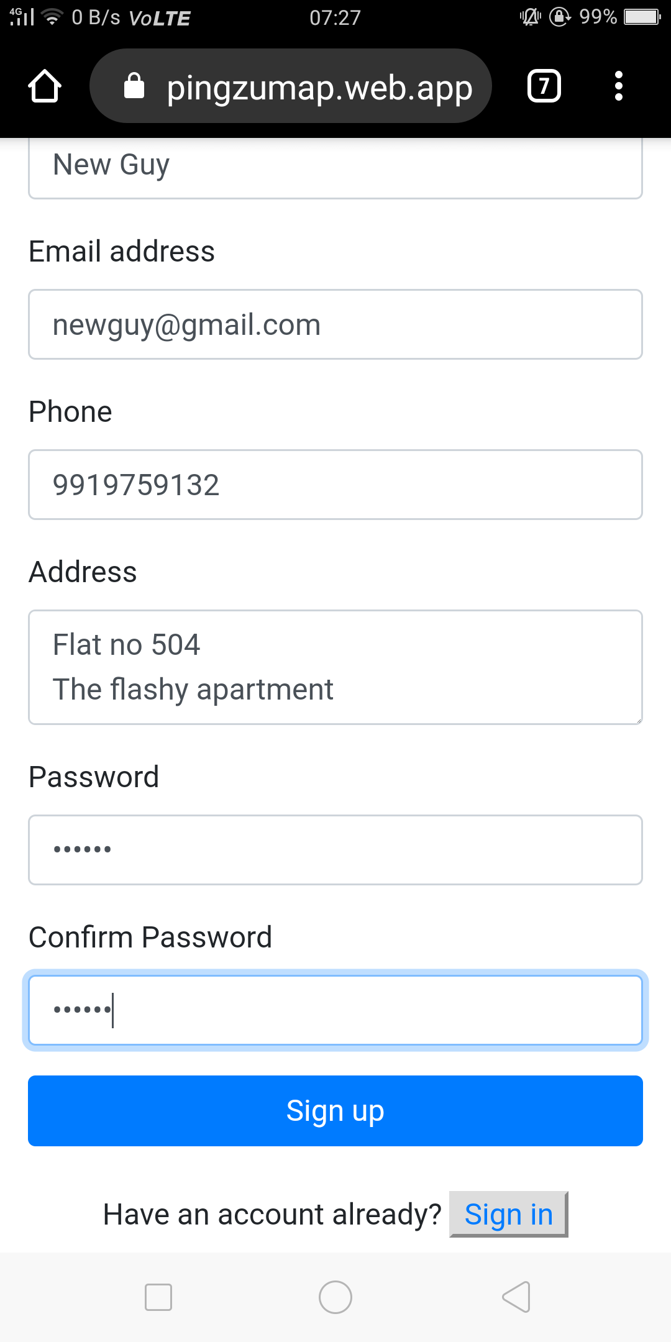

*Figure 8.1: Customer signup .*

Figure 8.2 shows the categories used in the search page- Search by shop or Search by products. Upon clicking any one of these, users will be taken to the search bar where they can search for the items they want.

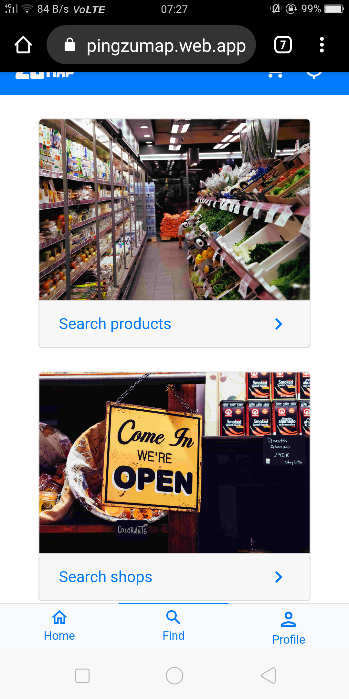

*Figure 8.2: search*

By searching for item lemon, users can click on the item and the item details page pops up as

shown in Figure 8.3. Upon doing this, clicks of the items are updated in firestore which would

then be used for machine learning purposes in the recommendation system.

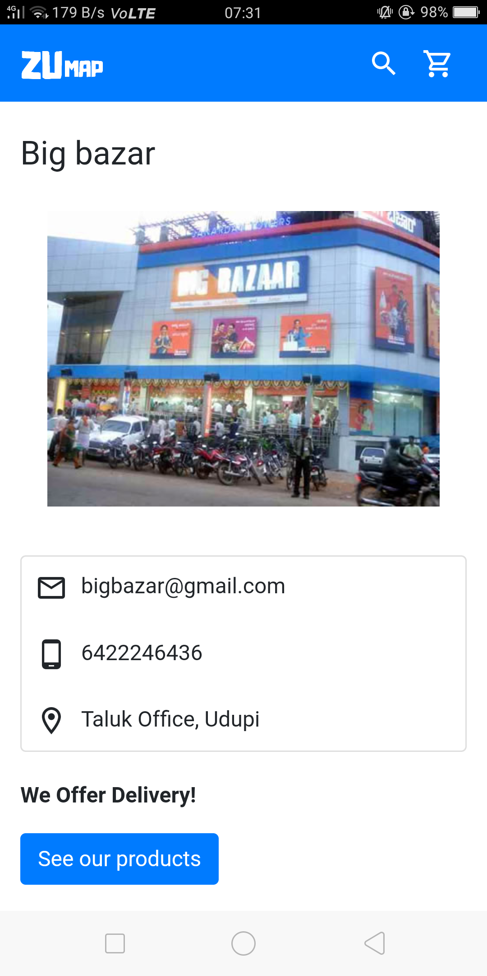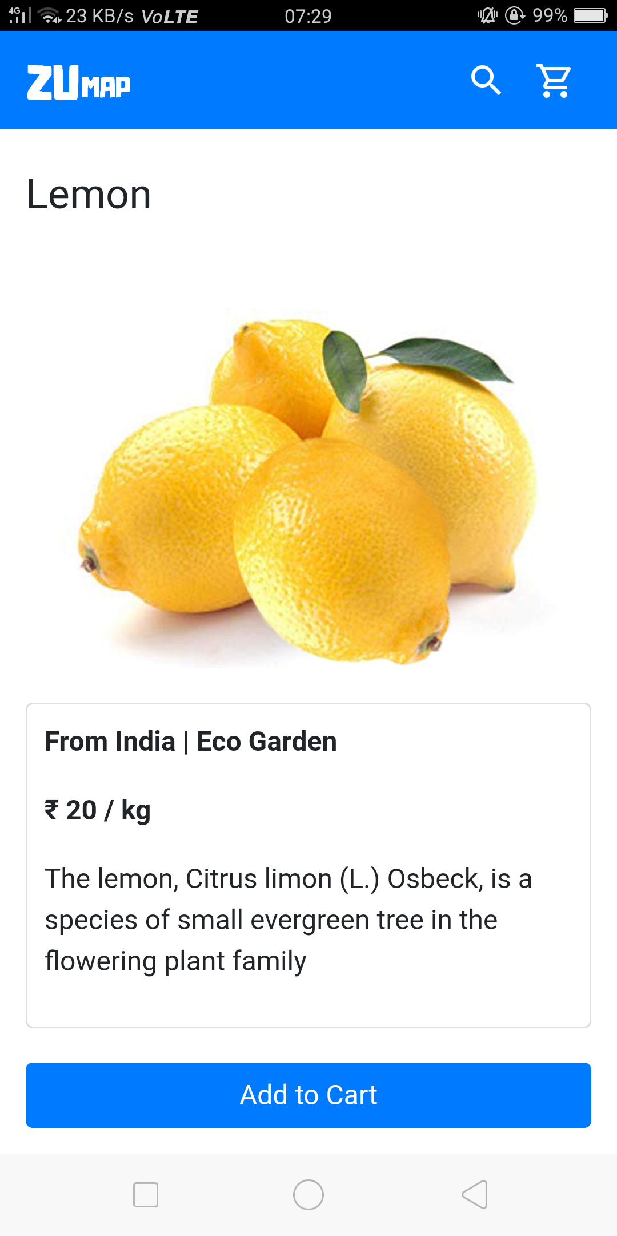

*Figure 8.3: shop and products*

Users has a choice to buy a product from multiple shops and select the quantity. The item lemon can be purchased from any of the two shops big bazar or Navami supermarket as illustrated in the Figure 8.4.

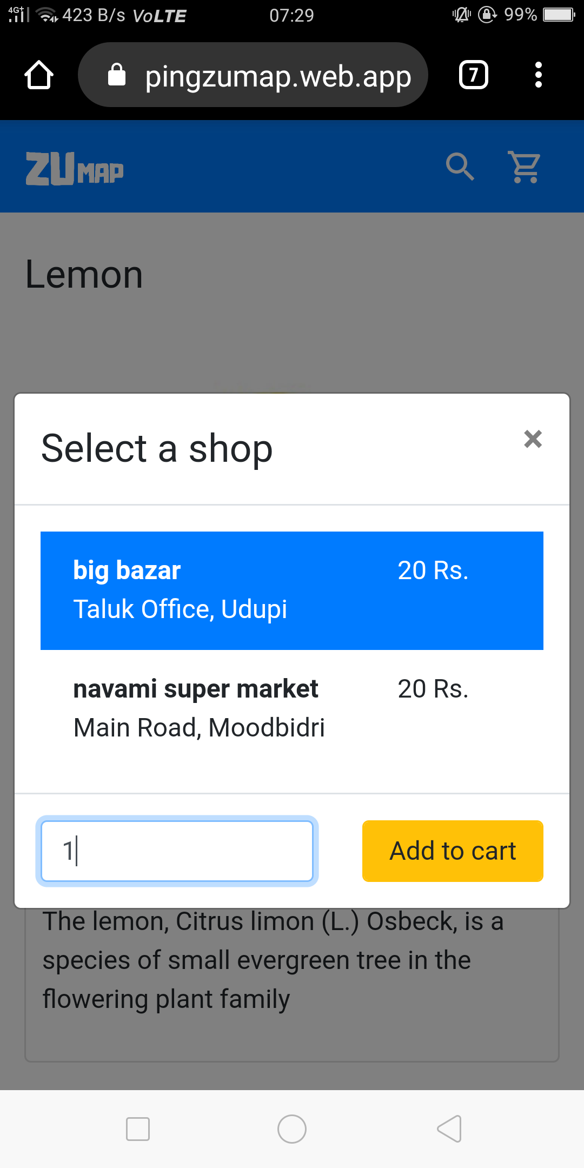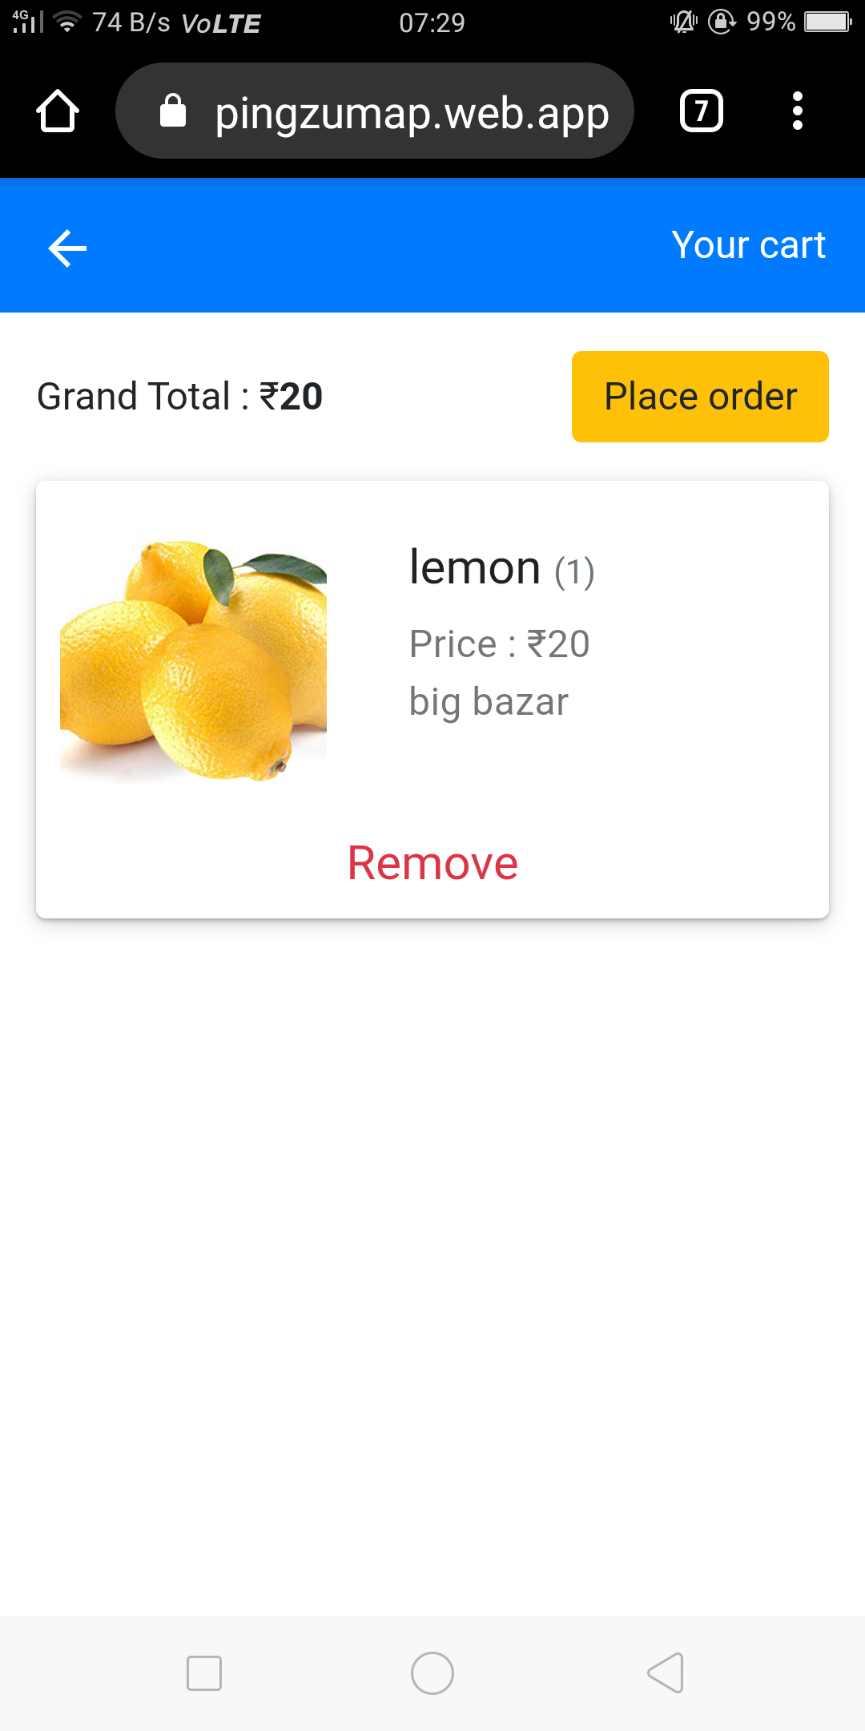

*Figure 8.4: selecting the shop and adding to cart*

At the Home page, recommendations are displayed as shown in Figure 8.5 with personal recommendations for the user. A user can choose to select these items or they can search for items in the search page.

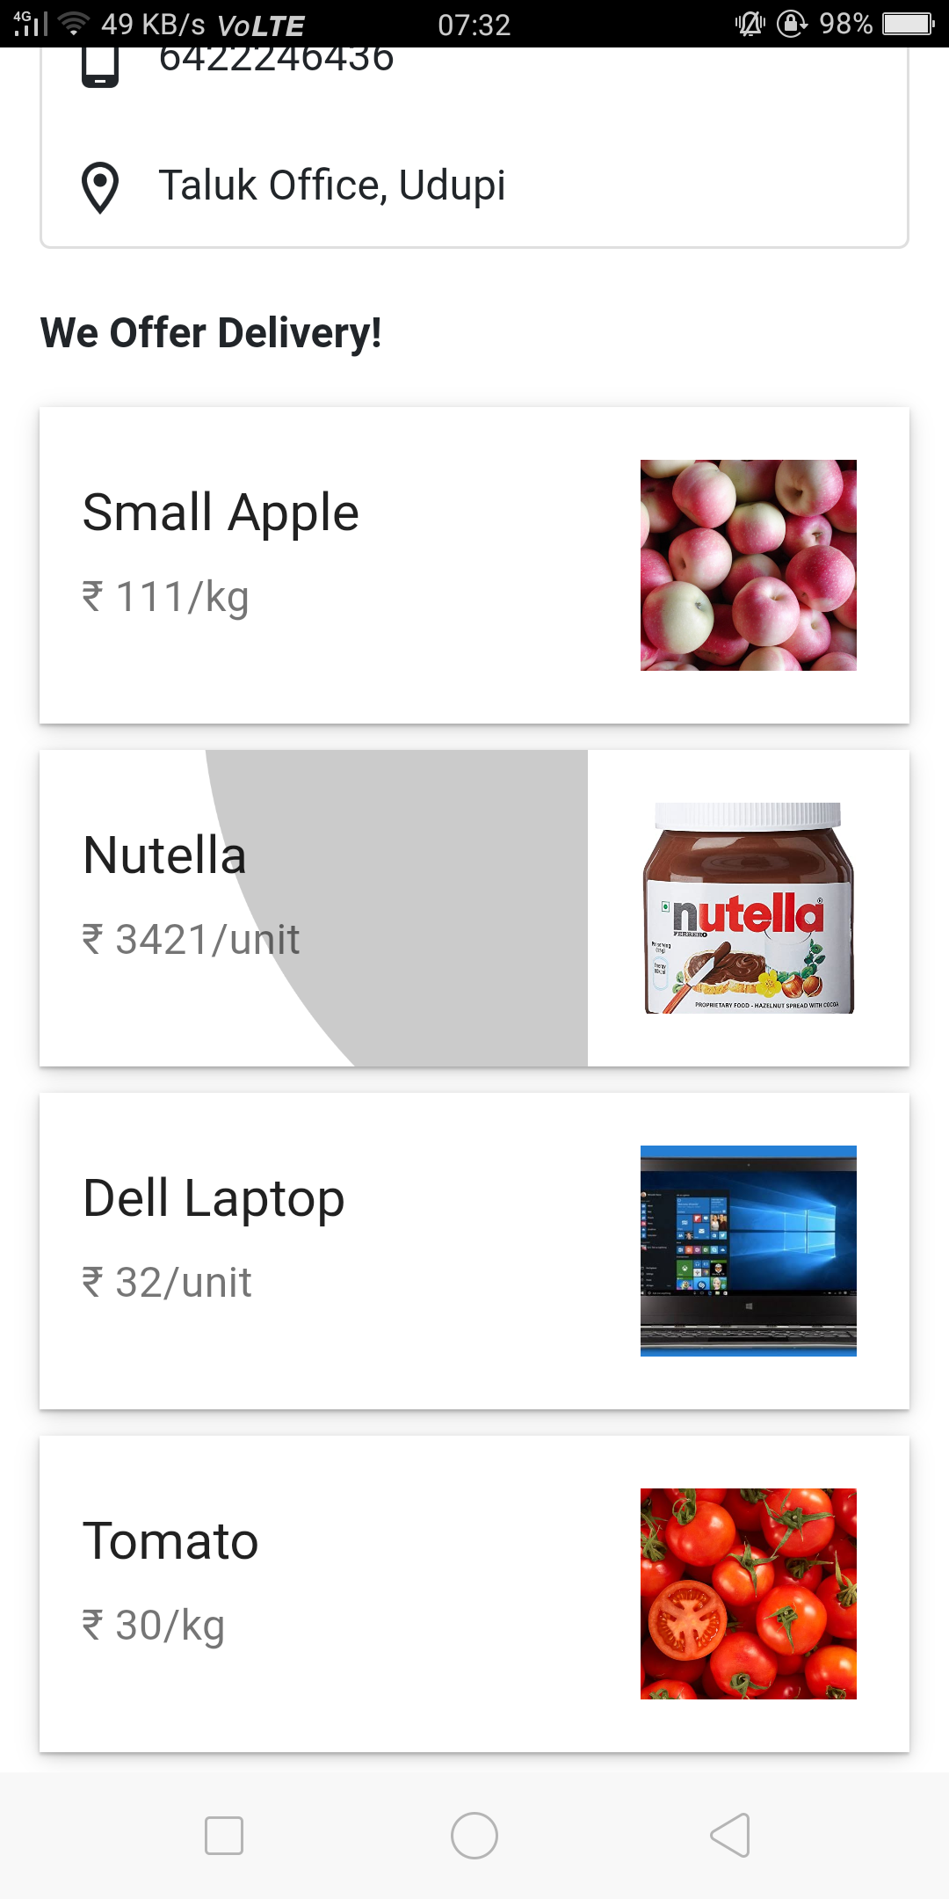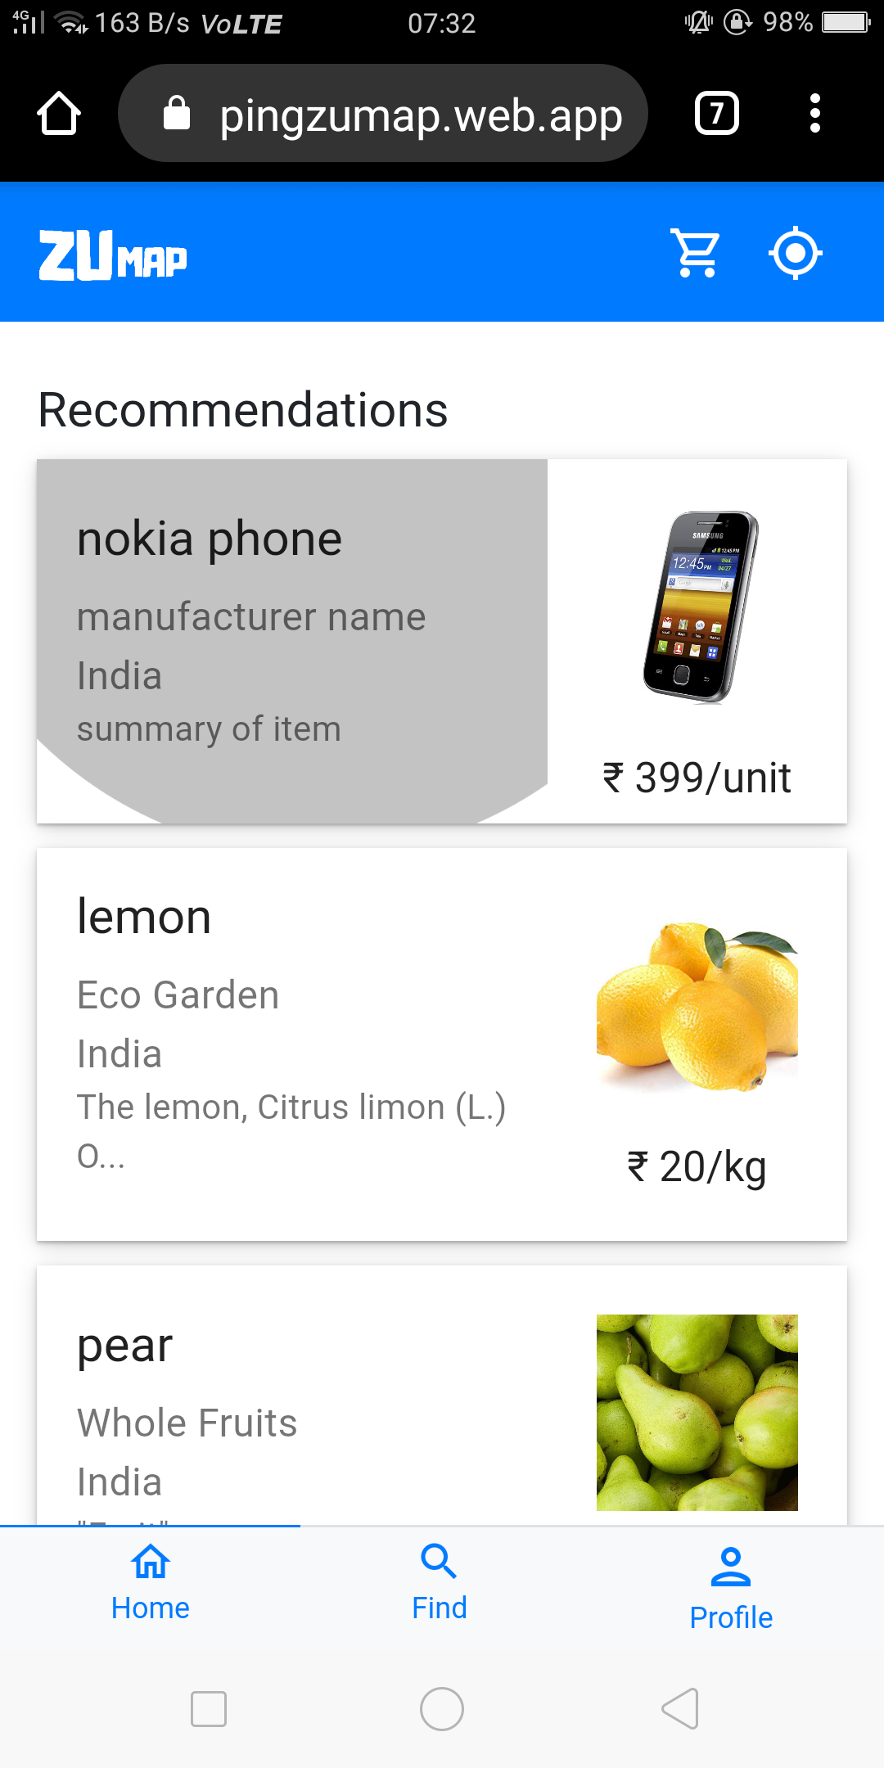

*Figure 8.5: Shop Items and recommendation*

### DISCUSSIONS

The main purpose of our project is to make the shopkeepers get more profits out of their business. Our project mainly aims at making the process time saving and more understanding for both customers as well as shopkeepers. For this purpose we have developed a webpage wherein we have added features like Collaborative filtering for recommending products to our customers based on their interest. This system helps local shopkeepers stay in business even during the times of popular e-commerce sites such as flipkart, amazon etc. It also helps customer order unique local products which online shopping sites don’t provide. Delivery of the products will be quick considering the shops are nearby which is an added advantage when compared to the current e-commerce sites.

## CHAPTER 9 CONCLUSION AND FUTURE WORK

### CONCLUSION

This system is a unique approach to online shopping where shopkeepers set up a virtual shop for the ones which already exist in real world. It helps the customers handle the trivial task of ordering items from their favorite local shops without even moving out of their house. This system combines the unique features of online shopping and offline shopping by melding it together and trying to absorb the best of both worlds. Of course, there are certain kinks to be worked out but we believe in future, we can overcome it

### FUTURE WORK

The system that we have currently developed has multiple features that benefits the user while interacting on the website. Further we want to focus more on making the website more user-friendly and appealing to the user of smaller ages to find the process more fun and engaging. We plan to focus on improving the overall performance of the system. Creation of a discussion forum that would be the base for the interaction between the customer and the shopkeeper on the website that would allow the students to clarify any kind of doubts they would have regarding the subjects they would be dealing with. We are also focusing on developing an android application for our model which is a better platform for interaction and each student can have it installed in their phones for flexible use.

## REFERENCES

1. Comparative Study of Online and Offline Shopping: A Case Study of Rourkela in Odisha
2. Practical Machine Learning Innovations in Recommendation by Ted Dunning and Ellen

Friedman

1. https://en.wikipedia.org/wiki/React_(web_framework)
2. Mozilla. JavaScript. Retrieved from https://developer.mozilla.org/en
3. https://en.wikipedia.org/wiki/Firebase
4. Node.js. Retrieved from https://nodejs.org/en/about/
5. https://www.geeksforgeeks.org/k-nearest-neighbours/
6. <https://stories.jotform.com/7-reasons-why-you-should-use-react-ad420c634247>
7. https://www.tristatetechnology.com/blog/firebase-backend-mobile-app/
8. <https://www.lynda.com/HTML-tutorials/HTML-Essential-Training/170427-2.html>
9. <https://medium.com/@mindfiresolutions.usa/how-important-is-javascript-for-modern-web-developers-2854309b9f52>
10. <https://www.interaction-design.org/literature/topics/ui-design>
11. <https://www.ministryoftesting.com/dojo/lessons/30-things-every-new-software-tester-should-learn>